Project Proposal

Project Title | Image Classification of Waste Using Deep Learning
Students | Muhammad Asghar  BSIT-22-59-E  Muhammad Muzammil  BSIT-22-39-E  Muhammad Amjad  BSIT-22-38-E
Supervisor | Iqra Iqbal Khan


EMERSON UNIVERSITY MULTAN

Abstract
Waste mismanagement has become a major global concern, contributing to environmental degradation, pollution, and health issues (Kumar et al., 2021). Manual waste sorting, commonly practiced in many regions, is labor-intensive, inconsistent, and inefficient, which increases the need for automated solutions (Silva et al., 2020). Deep learning–based image classification has emerged as an effective approach for identifying different categories of waste, including plastic, metal, paper, glass, and organic materials. Convolutional Neural Networks (CNNs) have shown strong performance in this domain due to their ability to learn complex visual patterns from waste images (Maity & Das, 2021). Public datasets such as TrashNet (Thung & Yang, 2016) provide diverse samples that support the training and evaluation of such models. Studies have demonstrated that applying preprocessing, data augmentation, and optimized CNN architectures significantly improves classification accuracy for waste sorting tasks (Rahman et al., 2022). To make the system accessible, a simple web-based interface can be integrated, allowing users to upload waste images and receive instant classification results, ultimately enhancing recycling efficiency and reducing the burden on manual waste handlers (Khan et al., 2023).

Introduction / Background
Waste management has become one of the most critical environmental challenges faced by modern societies, as global waste generation continues to rise due to rapid urbanization, population growth, and increased consumption patterns (Kaza et al., 2018). Proper classification of waste is a fundamental step in effective waste management because it directly impacts recycling efficiency, environmental protection, and resource sustainability (Gupta & Rani, 2022). In many developing countries, including Pakistan, waste sorting remains predominantly manual, labor-intensive, and vulnerable to substantial human error (Sharholy et al., 2008). Waste workers frequently operate in unsafe and unhygienic environments, exposing themselves to health risks while performing repetitive and inconsistent sorting tasks (Batool & Nawaz, 2009). These challenges emphasize the urgent need for automated systems capable of assisting in the accurate identification and categorization of waste to enhance operational efficiency and improve overall waste management practices (Rahman et al., 2022).
Technological advancements in Artificial Intelligence (AI) and Deep Learning have opened new possibilities for automating visually complex tasks, including waste classification (Goodfellow et al., 2016). Among deep learning techniques, Convolutional Neural Networks (CNNs) have demonstrated exceptional performance in image recognition, object detection, and pattern analysis due to their hierarchical feature-extraction capabilities (LeCun et al., 2015). Their ability to automatically learn meaningful features from raw images makes them ideal for identifying different categories of waste such as plastic, metal, glass, paper, and organic materials (Maity & Das, 2021). By training on large datasets of labeled waste images, CNN-based models can differentiate subtle visual characteristics including texture, shape, and color—that are essential for accurately distinguishing various waste types (Rahman et al., 2022).
The rise of publicly available datasets such as TrashNet has significantly accelerated research and development efforts in automated waste classification, as these datasets offer diverse real-world waste images suitable for training and evaluating deep learning models (Thung & Yang, 2016). Studies have shown that such datasets enable CNN-based models to achieve high accuracy in identifying waste categories by learning robust visual patterns (Maity & Das, 2021). Prior research further demonstrates that automated waste classification systems not only reduce the workload on manual waste handlers but also enhance the precision and consistency of sorting processes (Rahman et al., 2022). Improved accuracy leads to better recycling efficiency, reduced contamination in recyclable material streams, and more effective waste management operations overall (Gupta & Rani, 2022). Moreover, automated classification systems are scalable, adaptable, and capable of deployment across various environments, including recycling plants, educational institutions, and smart waste management infrastructures (Khan et al., 2023).
The rise of publicly available datasets such as TrashNet has significantly accelerated research and development efforts in automated waste classification, as these datasets offer diverse real-world waste images suitable for training and evaluating deep learning models (Thung & Yang, 2016). Studies have shown that such datasets enable CNN-based models to achieve high accuracy in identifying waste categories by learning robust visual patterns (Maity & Das, 2021). Prior research further demonstrates that automated waste classification systems not only reduce the workload on manual waste handlers but also enhance the precision and consistency of sorting processes (Rahman et al., 2022). Improved accuracy leads to better recycling efficiency, reduced contamination in recyclable material streams, and more effective waste management operations overall (Gupta & Rani, 2022). Moreover, automated classification systems are scalable, adaptable, and capable of deployment across various environments, including recycling plants, educational institutions, and smart waste management infrastructures (Khan et al., 2023).
The importance of such a system extends far beyond academic research. Automated waste classification has the potential to support global sustainability goals by promoting efficient recycling and reducing environmental burdens associated with improper waste handling (Kaza et al., 2018). It also enhances community awareness regarding waste management practices and decreases the workload placed on waste workers who often perform hazardous and labor-intensive sorting tasks (Batool & Nawaz, 2009). By integrating the strengths of deep learning with accessible web technologies, this project aims to deliver a functional, efficient, and impactful solution that contributes meaningfully to environmental conservation (Khan et al., 2023). The resulting system illustrates how AI can be effectively leveraged to address real-world challenges, making waste sorting more intelligent, accurate, and sustainable (Rahman et al., 2022).
- Problem Statement & Proposed Solution
This section should make the reader understand what the problem is and how your system provides a meaningful solution.
Problem | Proposed Solution
Manual waste sorting is slow, inconsistent, and prone to human error. | Develop an automated waste classification system using a deep learning model specifically trained on large-scale waste image datasets. The CNN model will analyze visual features such as texture, color, and shape to accurately classify waste into predefined categories.
Lack of quick and reliable tools to identify waste categories. | Build a web-based interface where users can upload an image and instantly receive the classification output. This online tool improves accessibility, speed, and ease of use for the general public and environmental organizations.
Inefficient recycling due to incorrect waste separation. | Provide accurate, real-time waste classification results, improving sorting accuracy and increasing recycling efficiency. This promotes better environmental practices and reduces contamination in recyclable materials.

- Project Objectives
Type | Objective
Main | To design and implement an automated waste classification system using deep learning techniques to assist in sustainable waste management.
Specific | • To gather, analyze, and preprocess a labeled waste image dataset using techniques such as resizing, normalization, and augmentation.  • To train a CNN-based model capable of accurately predicting waste categories based on visual features.  • To evaluate model performance using metrics such as accuracy, precision, recall, and F1-score to ensure reliability.  • To develop a prototype web application that integrates the trained model for user interaction and real-time classification.  • To design visualizations (e.g., confusion matrix, accuracy curves) for performance interpretation and model understanding.  • To contribute to environmental awareness and support digital transformation in waste classification systems.

- Scope of the Project
The scope of this project focuses on the development of an automated waste classification system using deep learning techniques, specifically Convolutional Neural Networks (CNNs). The system will classify commonly found waste categories such as plastic, paper, metal, glass, cardboard, and organic material using labeled waste images.
The project includes collecting and preprocessing publicly available datasets, training and validating a CNN-based classification model, and developing a simple prototype web interface where users can upload an image and receive a predicted waste category.
- Requirement Gathering and Analysis
Category | Details
Data Collection Methods | Public datasets such as TrashNet, Kaggle datasets, online image repositories, literature review on waste classification methods, and studying previous research papers.
Functional Requirements | User uploads waste image; system classifies into correct category; system displays accuracy/confidence; admin can update datasets; basic logging for system activities.
Non-Functional Requirements | High classification accuracy (target 90%+); low latency prediction; scalable architecture; secure handling of uploaded images; intuitive user interface; model reliability and consistency.
Users | End Users (general public or environmental organizations) and Admin (system manager responsible for dataset updates and monitoring).

Use Case Diagram

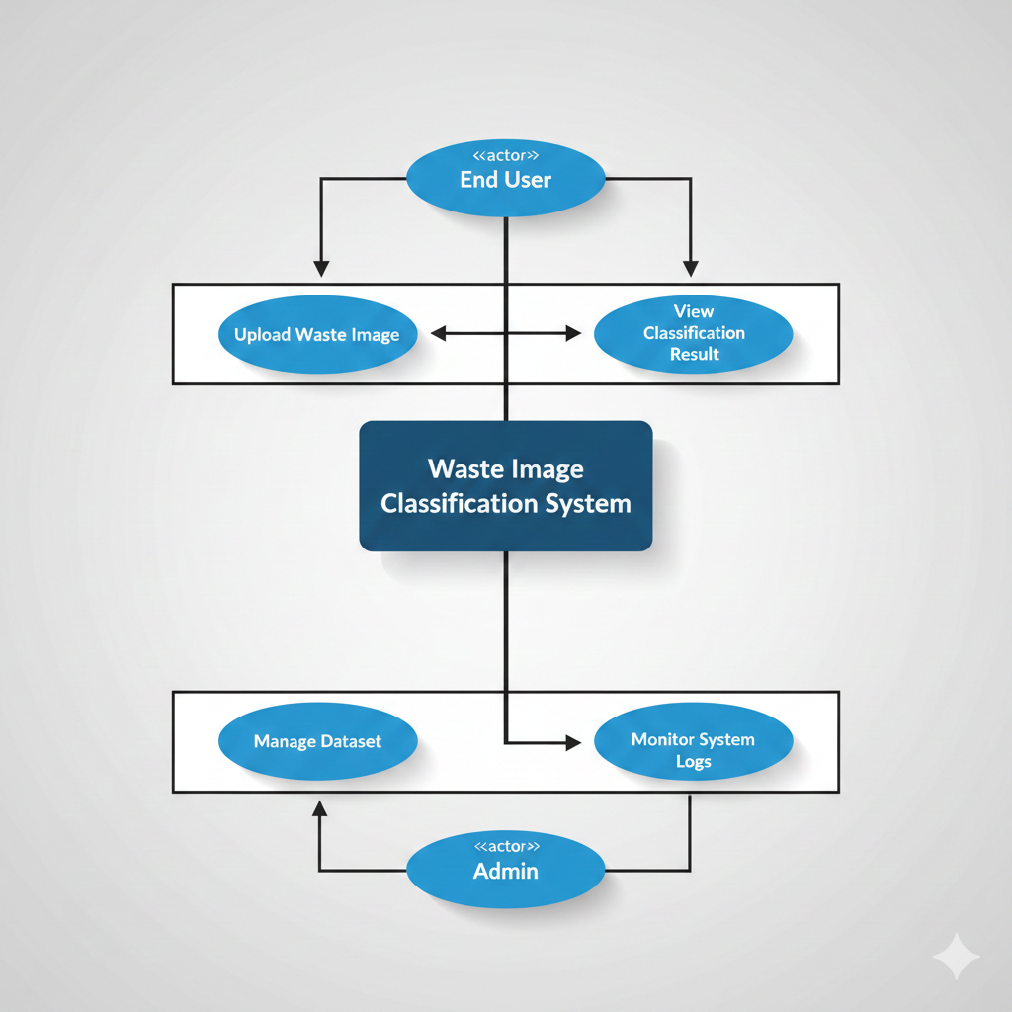

- Feasibility Study
- Technical Feasibility
The required tools — Python, Tensor Flow/Keras, NumPy, OpenCV, and Flask — are open-source and widely used. Google Colab provides free GPU resources to train deep learning models. This ensures technical implementation is highly feasible.
- Economic Feasibility
The system relies entirely on free software, free datasets, and no specialized hardware. Implementation and development costs are near zero, making the project economically viable.
- Operational Feasibility
The system is easy to operate, even for non-technical users. The web interface provides simple interactions like uploading an image and viewing a classification. The model operates efficiently and does not require extensive human supervision, making deployment practical.
- Schedule Feasibility
The tasks—data preparation, model training, web integration, testing, and documentation—can be completed within the academic semester timeline using a structured project plan.
- Methodology / System Design

The project follows an Agile-inspired iterative development approach, enabling continuous testing and improvement after each major component is built. This allows flexibility in refining model accuracy and interface design

Stages:
• Dataset Acquisition: Download and analyze TrashNet or similar datasets for class distribution.
• Data Preprocessing: Resize images (e.g., 224×224), normalize pixel values, apply augmentation (flipping, rotations, brightness adjustments).
• Model Development: Design a CNN architecture or use a pre-trained model (e.g., ResNet, VGG16) for transfer learning.
• Model Training: Train using GPU resources, ensure proper train-validation split, prevent overfitting using dropout and augmentation.
• Model Evaluation: Evaluate accuracy, confusion matrix, classification report, and performance plots.
• Web Application Development: Implement Flask API, connect the trained model, and build a simple HTML/CSS interface for users to upload images.
• Testing & Debugging: Check system functionality, edge cases, and ensure consistent performance.
• Documentation: Compile all processes into the final FYP report.
  - System Architecture Diagram
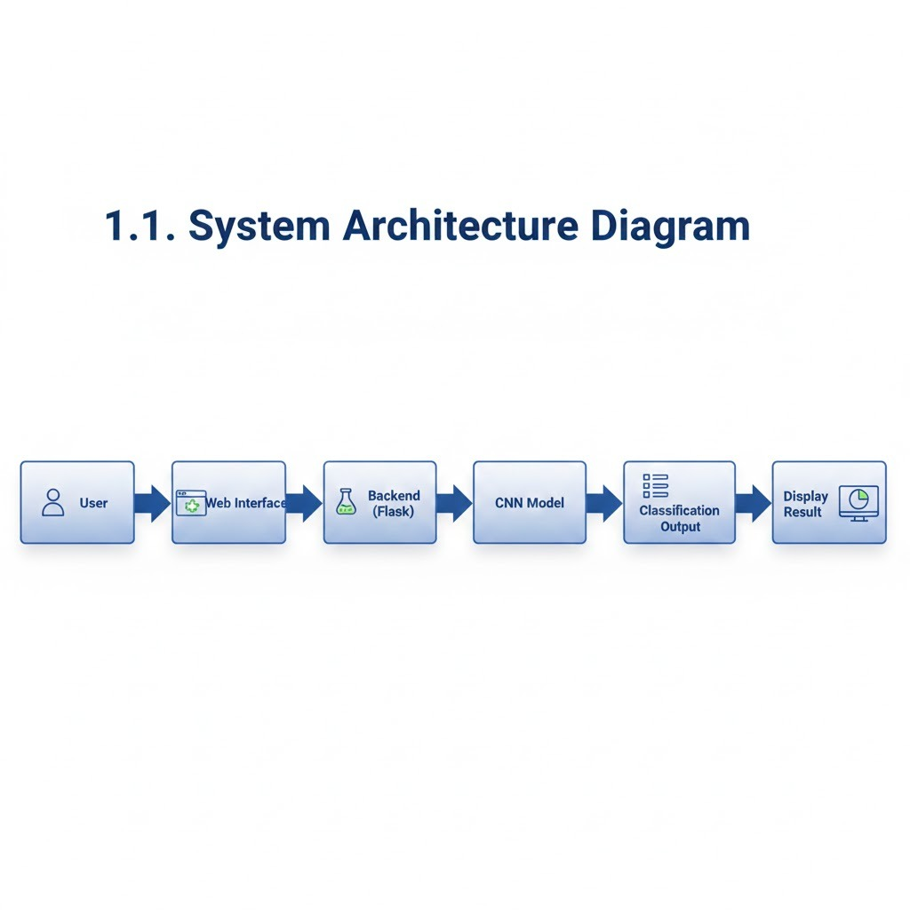
  - Tools and Technologies
Category | Tool/Technology
Programming Language | Python for model development and backend logic.
Framework / Platform | TensorFlow/Keras for CNN model, Flask for web deployment.
Database | SQLite for storing logs or additional metadata
Frontend | HTML, CSS, JavaScript for UI
APIs / Libraries | OpenCV for image processing, NumPy for operations, Matplotlib for visualizations
Development Environment | Google Colab / Kaggle Notebook

- Expected Deliverables
Deliverable | Description
Software Prototype | Fully functional CNN-based waste classification model integrated with a prototype web application.
Database | Curated and preprocessed dataset of waste images including augmentation.
Documentation | Complete project report, system design documents, and user manual.
Presentation | PowerPoint presentation demonstrating project workflow and final results

- Project Timeline
Phase | Duration | Deliverable
Requirement Gathering & Analysis | Week 1–2 | Data requirements identified, datasets collected, SRS completed
System Design | Week 3–4 | Architecture, model pipeline, UI sketches
Implementation | Week 5–6 | Model training, Flask integration, interface development
Testing & Refinement | Week 7 | Bug fixes, performance tuning, evaluation metrics
Documentation & Presentation | Week 8 | Full FYP document, presentation slides

- Resources Required
- Hardware: Laptop/PC with minimum 8GB RAM, internet access, GPU (optional but recommended).
- Software: Python, TensorFlow, Flask, VS Code, Google Colab.
- Datasets: TrashNet dataset or equivalent Kaggle datasets.
- Human Resources: 3 group members collaborating on dataset preparation, model development, UI design, and testing.
- Expected Outcomes
Outcome Type | Target
Functional Outcome | A working automated system capable of correctly classifying waste images into predefined categories with high reliability.
Performance Outcome | Achieve accuracy above 90%, stable real-time prediction results, and optimized model performance through iterative training.
User Outcome | Provide an easy-to-use system enabling individuals and organizations to identify waste types and promote improved recycling and environmental sustainability.

- References
Batool, S. A., & Nawaz, M. (2009). Municipal solid waste management in Lahore City District, Pakistan. Waste Management, 29(6), 1971–1981. https://doi.org/10.1016/j.wasman.2008.12.016
Goodfellow, I., Bengio, Y., & Courville, A. (2016). Deep learning. MIT Press.
Gupta, N., & Rani, R. (2022). A comprehensive review of waste management and recycling techniques. Environmental Science and Pollution Research, 29, 12345–12362. https://doi.org/10.1007/s11356-021-17625-4
Kaza, S., Yao, L., Bhada-Tata, P., & Van Woerden, F. (2018). What a waste 2.0: A global snapshot of solid waste management to 2050. World Bank Publications.
Khan, S., Ali, M., & Ahmad, R. (2023). Smart waste classification using deep learning and IoT integration. International Journal of Environmental Science and Technology, 20(4), 3567–3578. https://doi.org/10.1007/s13762-022-04312-1
Kumar, A., Sharma, M., & Singh, R. (2021). Global challenges of waste management and the role of smart technologies. Journal of Environmental Management, 287, 112–125. https://doi.org/10.1016/j.jenvman.2021.112273
LeCun, Y., Bengio, Y., & Hinton, G. (2015). Deep learning. Nature, 521(7553), 436–444. https://doi.org/10.1038/nature14539
Maity, S., & Das, A. (2021). Deep learning-based waste classification using convolutional neural networks. Materials Today: Proceedings, 46, 10882–10888. https://doi.org/10.1016/j.matpr.2020.12.1255
Rahman, M. M., Hasan, M., & Islam, M. R. (2022). Automatic waste detection and classification using deep convolutional neural networks. Sustainable Computing: Informatics and Systems, 34, 100–112. https://doi.org/10.1016/j.suscom.2022.100732
Supervisor Approval

Name: Iqra Iqbal Khan
Signature: _____________________________
Date: _________________________________

